**OUTPUT SCREENS FOR THE PROJECT**

1. **The main Home page of ERP system which contains dashboard**

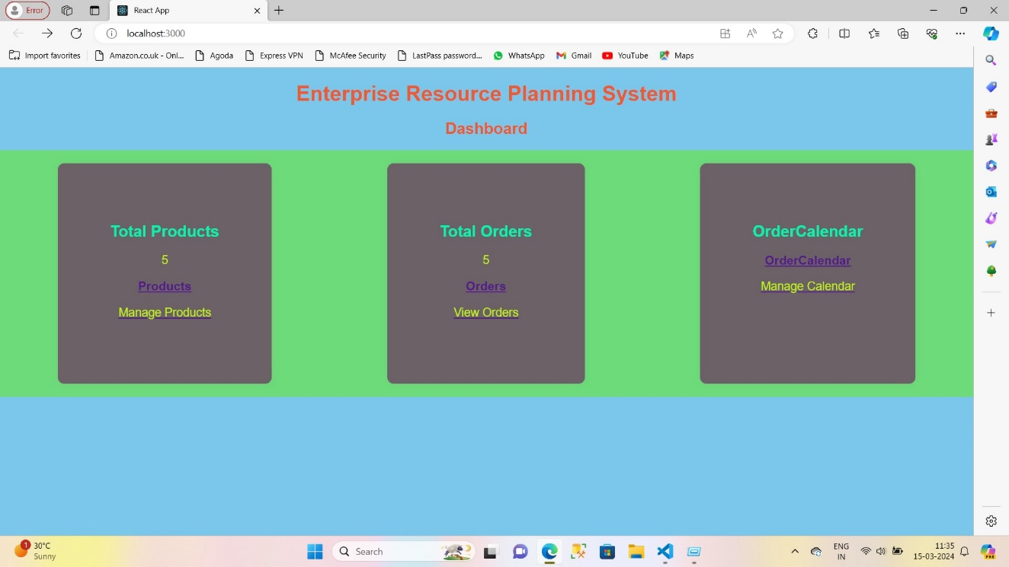

1. **The dashboard contains three sections:**

* Total products
* Total Orders
* OrderCalendar

1. **The Total products page:**

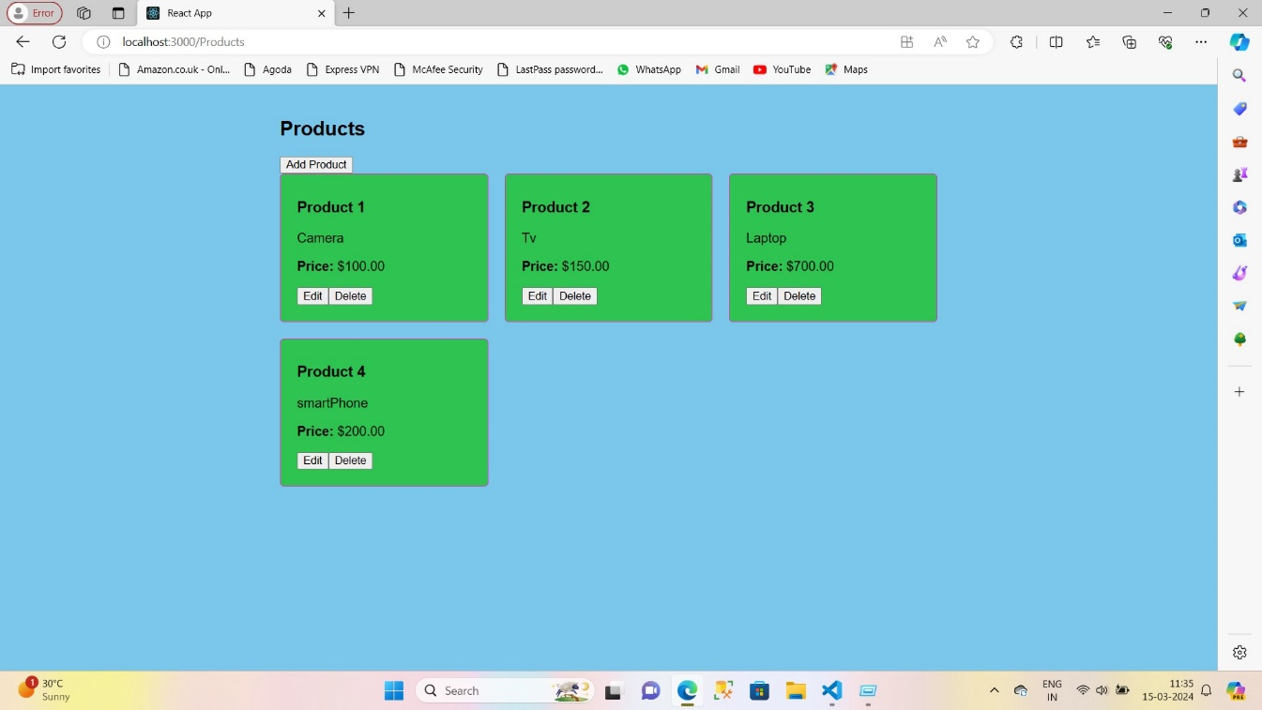

* **We can add , edit and delete the products**

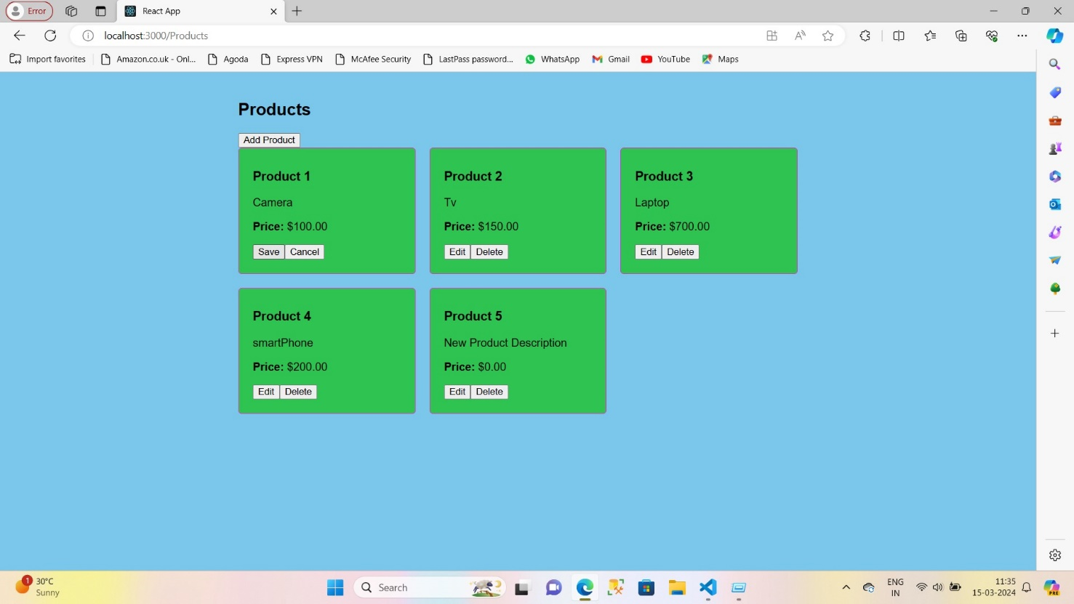

1. **The Total orders page**

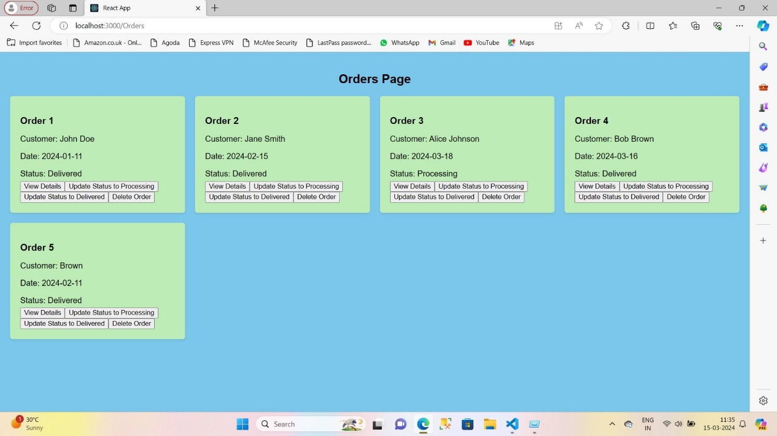

* **We can view details, update status to processing and update status processing to delivered**

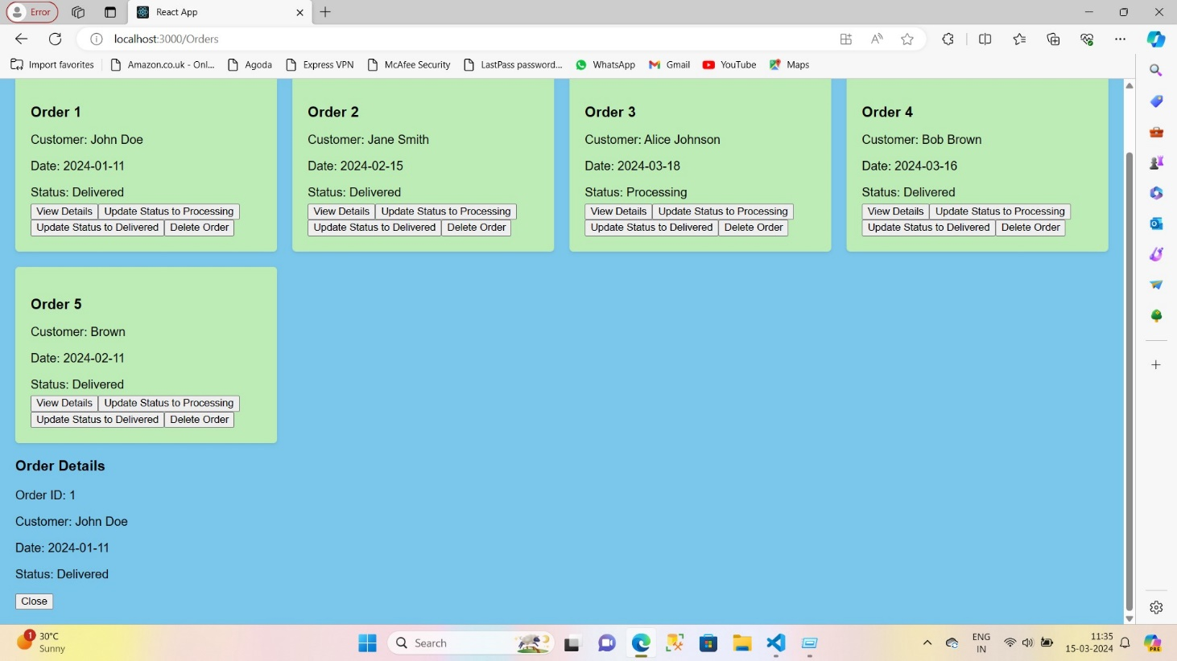

1. **OrdersCalendar**

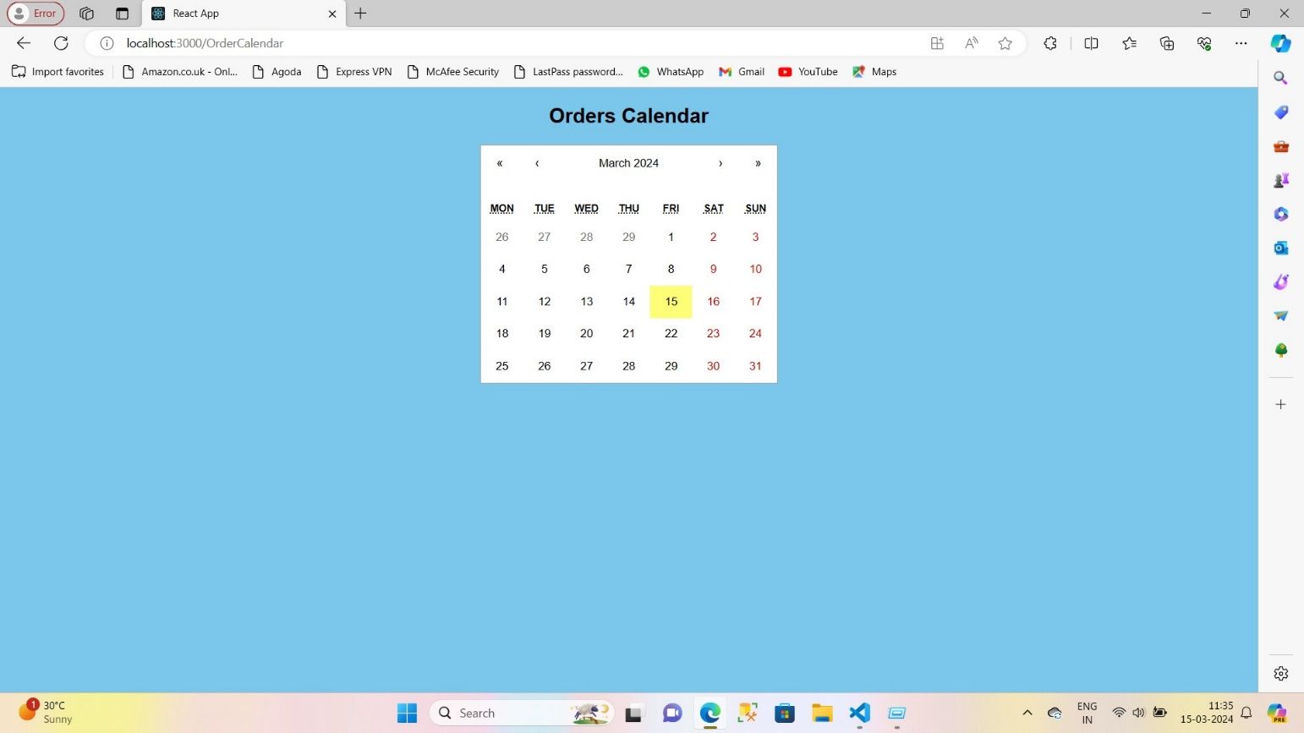

* We can see orders on a particular date
* 